GRADE 7 ACCELERATED · UNIT 2 · LESSON 6
Plotting, Ordering and Comparing Real Numbers
Additional Practice 7A.02.06 ANSWER KEY

Optional practice. Same four parts, different numbers.
PART 1. Comparing
Use <, > or =. One of the six is an equality.
1. | 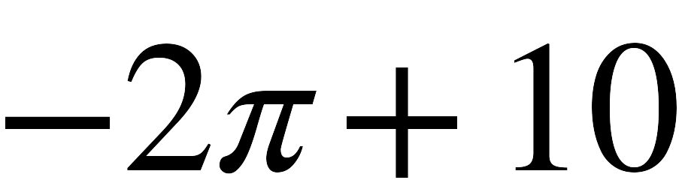 | > | 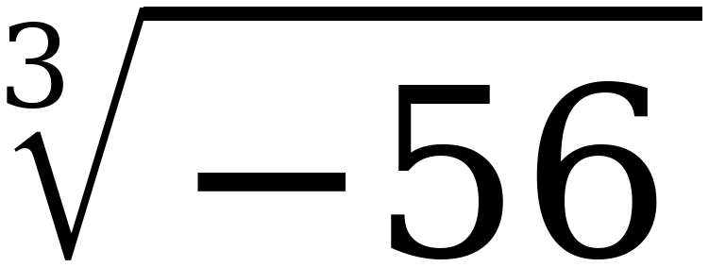
2. | 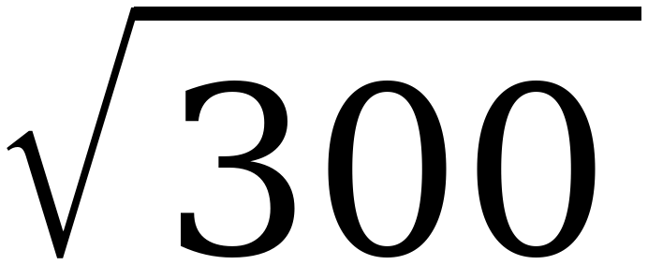 | < | 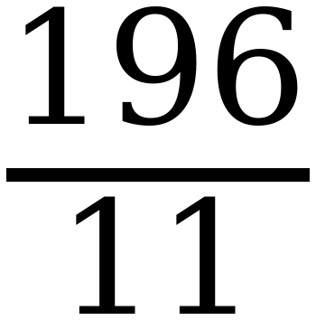
3. | 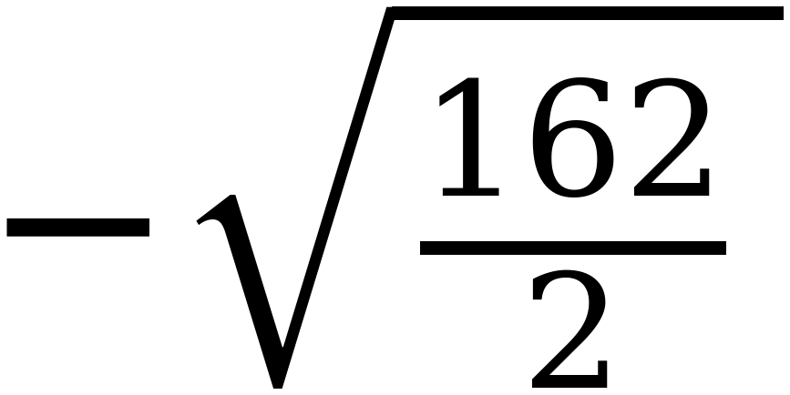 | > | 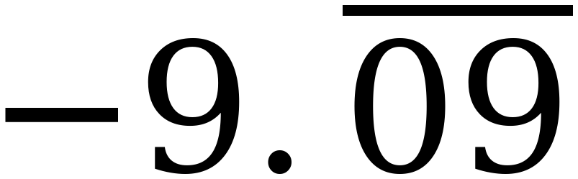
4. | 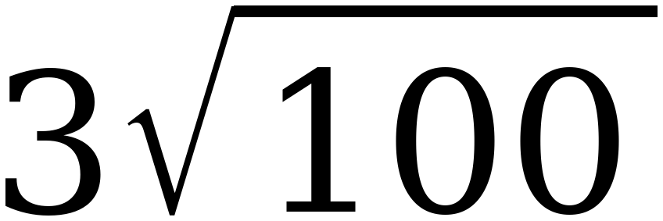 | < | 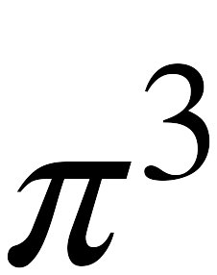
5. | 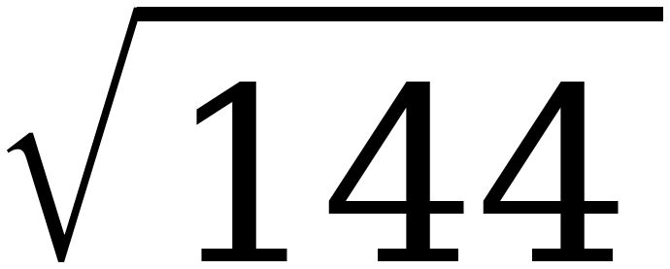 | = | 12
6. | 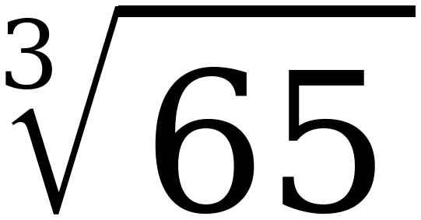 | < | 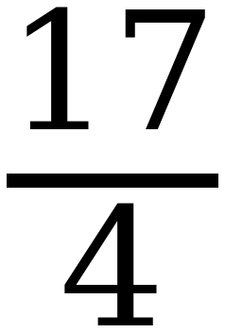

Values: 3.717 vs −3.826; 17.321 vs 17.818; −9 vs −9.0909; 30 vs 31.006; 12 vs 12; 4.021 vs 4.25. Row 3 is the one to slow down on: 162 ÷ 2 = 81, so the radical is exactly −9.
PART 2. Sorting and plotting
A number is irrational only if it cannot be written as a ratio of two integers.
7. Sort the five expressions, then plot and label each one on the number line.
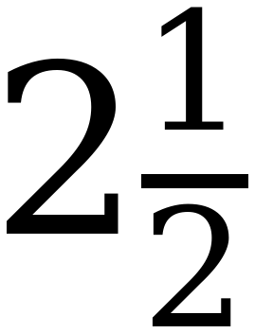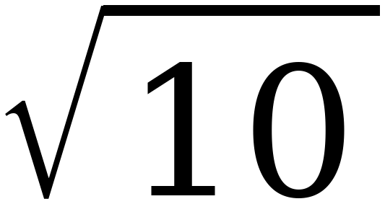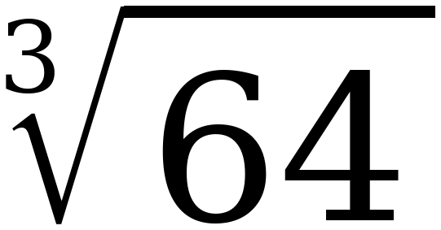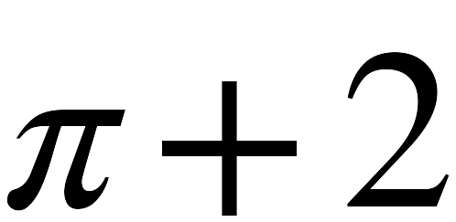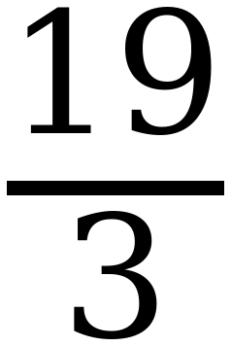
Only rational numbers | Includes an irrational number
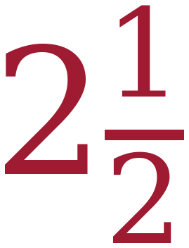 | 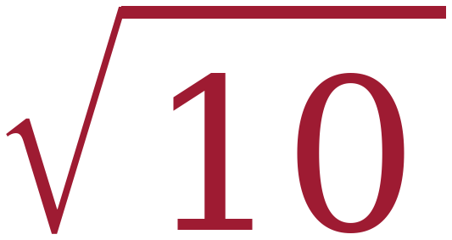
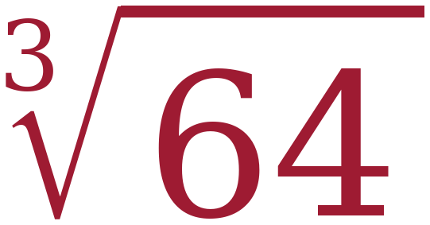 | 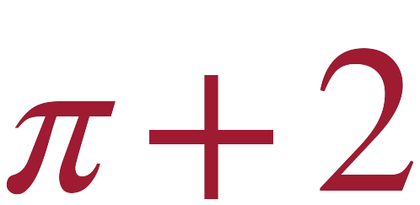
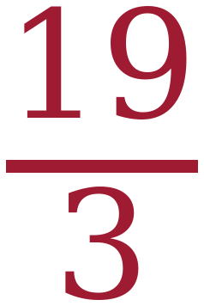

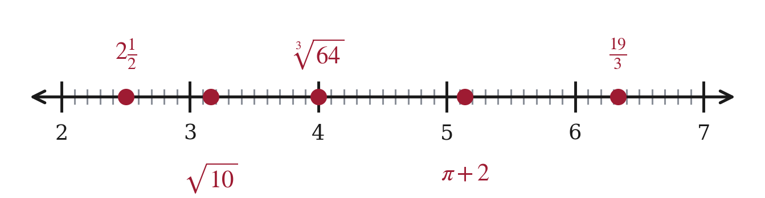
∛64 = 4 exactly, so it is rational — the circuit's ∛64 + 8 trap, one step shorter. Values: 2.5; 3.162; 4; 5.142; 6.333.
8. Plot and label each expression on the number line.
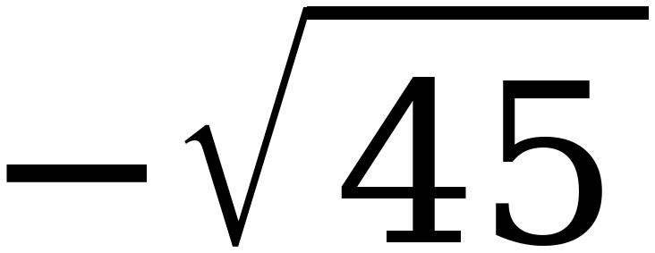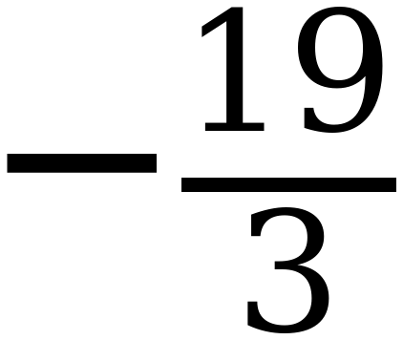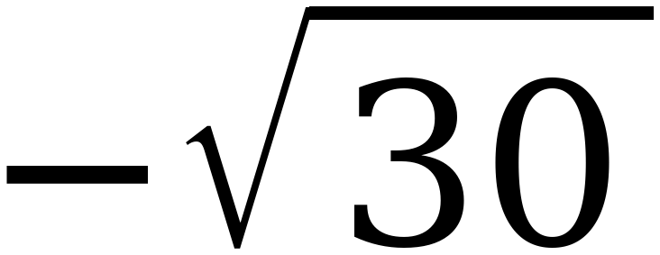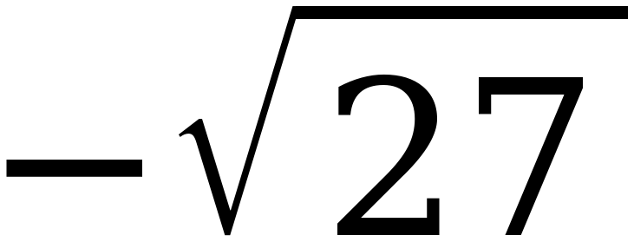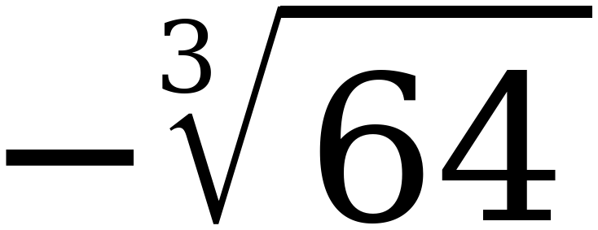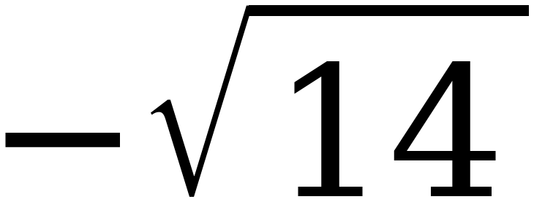
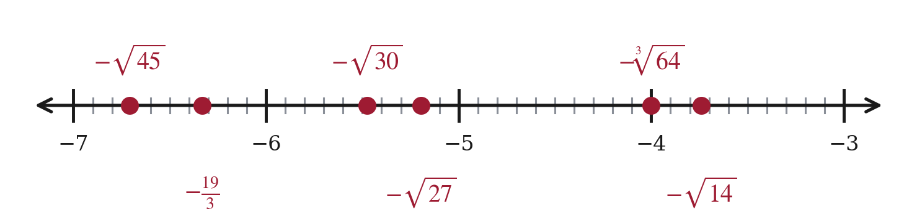
Values: −6.708; −6.333; −5.477; −5.196; −4; −3.742. −√30 and −√27 sit less than three tenths apart, so one of those two labels goes below the line.
PART 3. Error analysis
Read the work, find the error, then do it correctly.
9. Devin approximated 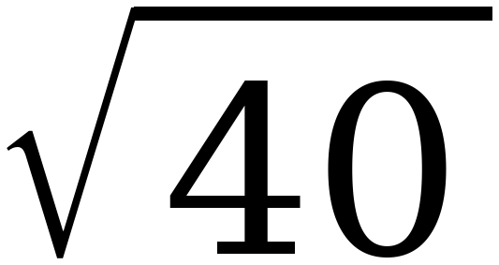 like this:
“40 is between the perfect cubes 27 and 64, so lies between 3 and 4.”
a. What is Devin's error?
He used perfect cubes to estimate a square root. He should have used perfect squares.
b. Redo it correctly.
40 lies between the perfect squares 36 and 49, so √40 lies between 6 and 7.
40 − 36 = 4 and 49 − 40 = 9, so 40 is closer to 36. √40 ≈ 6.3
This is Sara's error from the circuit, running the other way. The index tells you which list to use.
PART 4. Ordering and plotting
10. Order the numbers from least to greatest, then plot and label each one.
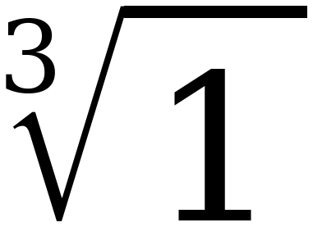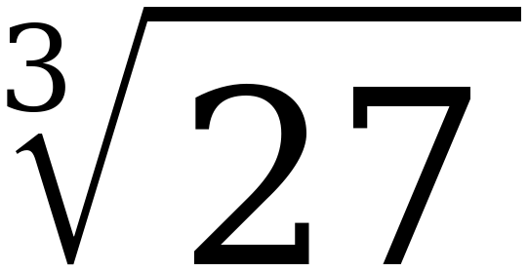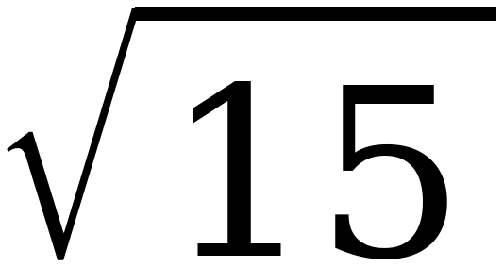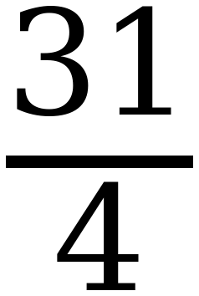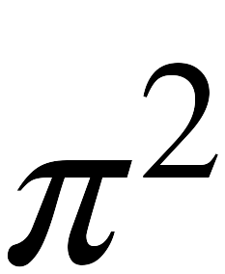
∛1 , ∛27 , √15 , √40 , 31/4 , π²
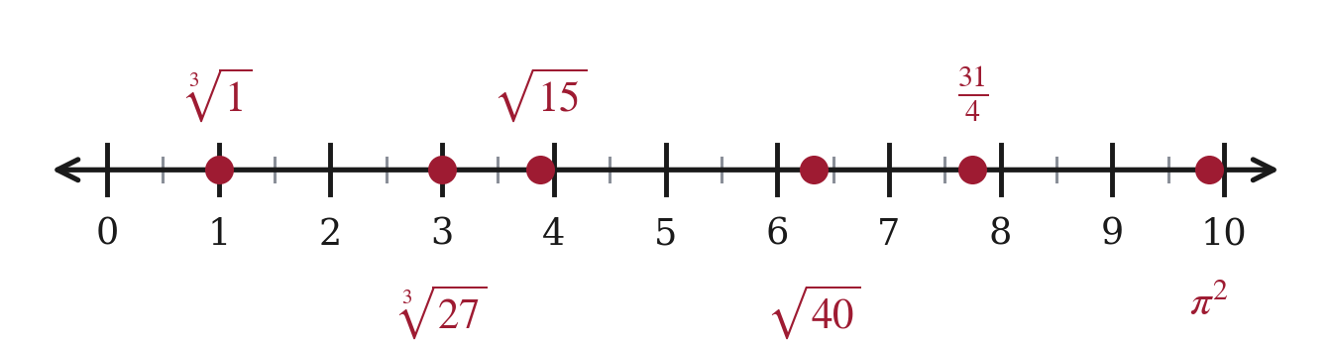
Values: 1; 3; 3.873; 6.325; 7.75; 9.870. Two of the six are whole numbers in disguise.
11. Order the numbers from least to greatest, then plot and label each one.
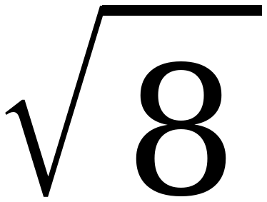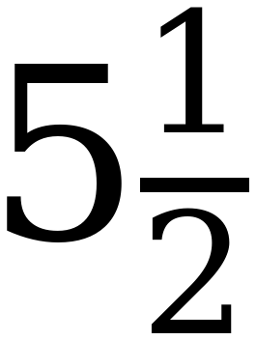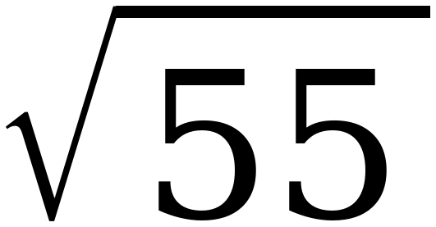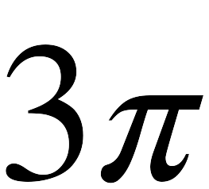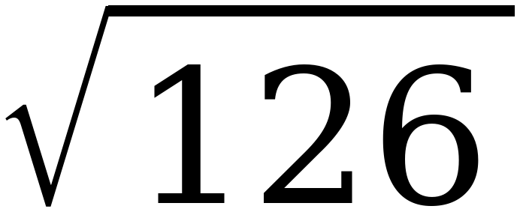
1/2 , √8 , 5½ , √55 , 3π , √126
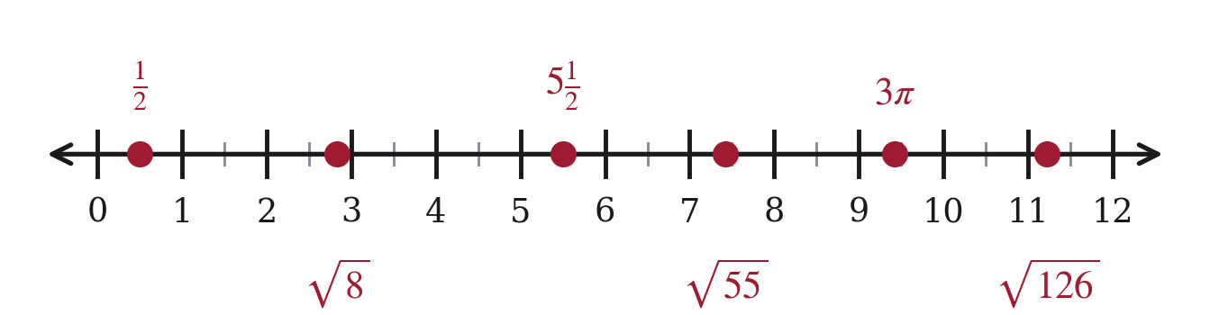
Values: 0.5; 2.828; 5.5; 7.416; 9.425; 11.225. π² in question 10 and 3π here are the two places a multiple of π has to be worked out rather than recognized.
STRETCH. Beyond the range the test uses. Same method, bigger cubes.
12. Find the value of 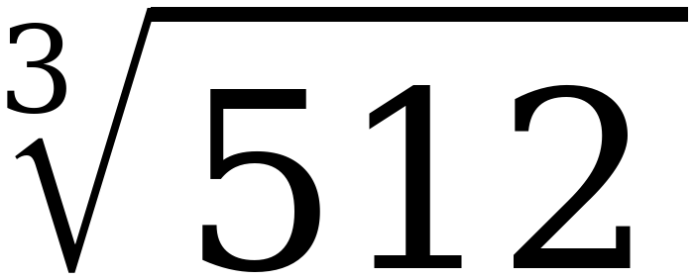 and of 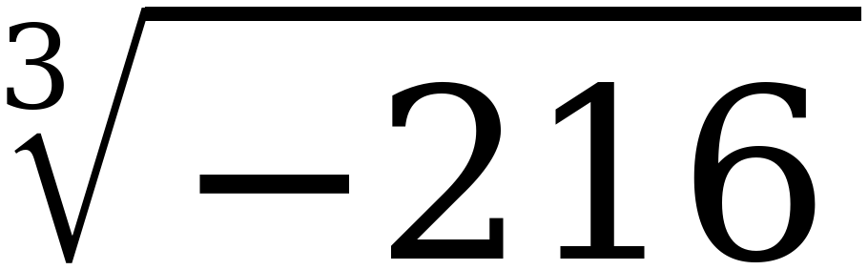.
∛512 = 8, because 8 × 8 × 8 = 512. ∛−216 = −6, because (−6)³ = −216.

